Trading 2016_10_17

Weekly to do list

1. focus on equity research, expand from current stock results
2. Birthday until now has been 4 months. What are your improvements? In Taiwan there were certainly chances. Take them. Assume positions of absolute advantage.
3. 华泰, 君安, 招商 I have available.

开户:国信

Markets:

@925 fut retreated, H lower as well. Rate worries continue to roil markets. A lesson from last week is that on Monday it is not good at add position. The position under water is because too much position was added last Monday. Take a hedging stance on Mondays. As people start selling off, Tuesday afternoon and Wednesday are more attractive.

This was an insight gained while doing research on shcomp.

@936 Another slew of session overtook the markets. All gains from last Friday on XU was erased. Buying at the premium is quite dangerous. Markets revert to parity fast after realizing that the index moves a lot less than the future.

@939 Pretty solid negative amFirst10. Doesn't warrant any buying.

@ 1600

Find out how to trade oil and gold

@1710

Monday daymax was in PM, and PM had a selloff which is good for tomorrow's afternoon trading. Started buying position on singles, futures and options. The sell-off might be related to RMB depreciation. After the China national holidays, H shares quickly receded 5% because A share has failed to rally contrary to expectations. USD has taken off another wave of rally with USDJPY and USDCNH both advancing massively.

Today H share did not go down that much reflecting that the selloff is calming down a bit.

**Tuesday**

H refused to sell off together with A in the late afternoon yesterday.

Markets rallied nicely today.

Picked up some position including gold, oil and vix.

Be careful of oil expiry because it is physical delivery.

The point is gain exposure to world equities.

Valuable stocks are a good hedge against inflation, especially consumer goods.

五粮液

1. come up with a list of stocks which are at their historical highs.
2. Stocks which had the best return in year 2016
3. Stocks which had best return in 5 years.

This forms a part of the long-short portfolio.

I am currently eligible to buy stocks for Fr, GB, HK, SG, Germany, and US. Considering stocks are at their historical highs, I bought some VIX to hedge against moves towards the end of the year.

How much equity risk are you actually taking on with the VIX position?

Today the market was strong. XU position was not quite sufficient. Market never gave much buying opportunity today. In terms of HK, market already seemed strong yesterday with A share tanking but HK staying stable. Today the move was more or less a continuation of yesterday's strength. Such strength was also seen in March when world market rallied.

The VIX position might be too heavy. Check if there are mini vix.

@1935 I am still down on the H share futures position. I got completely screwed on this position because of buying on a Monday. XU level is finally trying to recover the gap on Sep 9th. However, position is half what it was before. This shows how important position sizing at different times are.

Buying is safer at **noon** or **after market**. The reason is market is the most panicky in the morning and usually inches back in the afternoon. Today there was no opportunity to buy in the morning, because the rally immediately started.

Currently the VIX position might be too heavy. Vols changing from 17-18 is very easy and that is already 5%, and with the current delta 17000, pnl would be 1k usd. However, looking at the historical trend, the lowest vol has been is 14. And the highest is about 20

@2201 The volatility of oil is amazing. It moves quite a lot, contrary to the slowness of China markets. VIX is also quite quick. The net position is quite big… The pnl move will be pretty insane overnight.

You should cut your crude/vix exposure.

Gold exposure is about 25K USD which is fine. (GC is big, 125710 USD per lot, QO is 65k per lot).

Crude exposure is about 50k which is too high, cut this to 25k by trading QM.

When the pnl becomes too big this takes away the mandate of the portfolio which is supposed to be Asian oriented. Steering away from the area of expertise is not good. Let gold+vix be a hedge and reduce oil speculative position.

Oil sometimes moves up or down 5%. This will be quite a big move. I need to titrate that risk up,

The point is focus on Asian market where you have more experience, adding some position in other asset classes will keep you more updated about world markets. Keep positioning light tho… no point to lose a fortune on stuff that I have no expertise on.

Going into tomorrow, focus on developing strategies on single stocks + stock selection. Pick out inflation-hedgers and keep trading around the position. Pick out about 5. 五粮液 is one.

Develop technical advantage in China/HK market. You spent a bit too much time looking at oil today. Oil/gold/vix. These are not the key revenue generators and should be limited only to the use of hedging. You should keep exposure of oil and gold to 25k each, and vix under 10k. VIX position is expected to pay off eventually at least temporarily. Oil is currently taking up 50k of delta, when you make back your loss I want you to cut this position to half the delta. The current swing of pnl on this position is too much.

**Wednesday**

Market @ 0.3 premium, selling off some position to keep position light.

GDP comes out, expected 6.7%, will print that number. Credit/GDP is at 2.5 and not sustainable.

Oil position cut to 25k from 50k to reduce volatility.

Vix position taking a hit but expected to pay off eventually in terms of event risk. This position is just insurance.

@925 HK etfs ended at a discount and FXI is at -0.15% discount. Market remains cautious on China due to the GDP figure coming out, however it will probably be a non-event. The figure out comes at 10am.

@Today

@1048 The vix position is bleeding. The worst scenario is HK underperforms US, which will cause VIX to tank.

For Thursday and Friday, I was in Guilin. HK was closed for Friday.

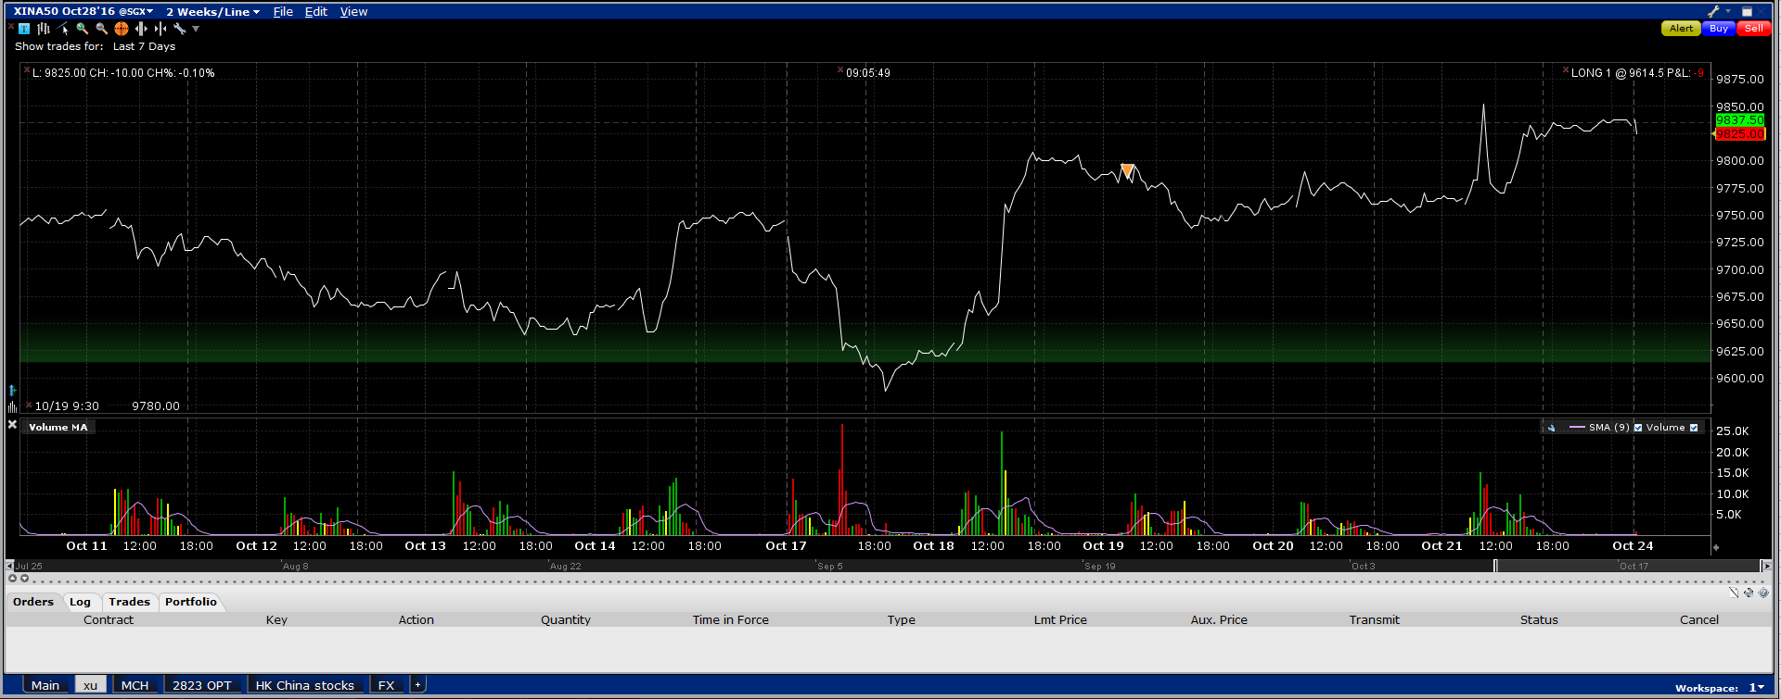

A50 fut was strong this week, net rising.